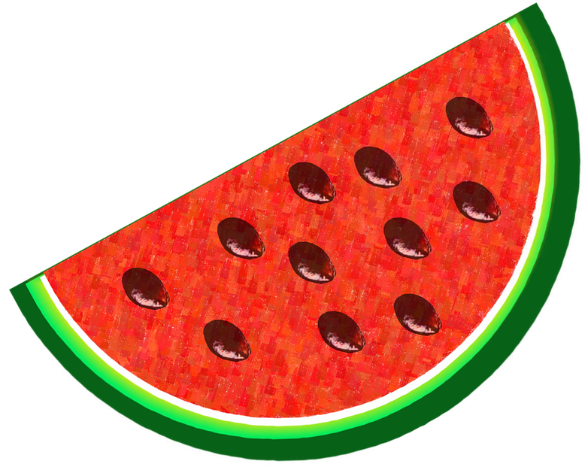
Watermelon

Use playdough to make the watermelon. Use beans for the seeds.

